CONFIDENTIAL VERIFICATION REQUEST

To: | Cristopher David | From: | Vanguard Screening Solutions, Inc
Attn: |  | Our contact details
 |  | Our email | renelyn.hantic@vanguardscreen.com
Fax: |  | Our fax: | (632) 8857 2889
Tel: | (0949) 647 1857 / david.toph@gmail.com | Our tel: | (632) 7902 9100

Dear Sir/Madam:

We are Vanguard Screening Solutions, Inc., a 100% Filipino-owned Corporation and the leading Employment Screening and Background Verification services provider in the Philippines. As part of their pre-employment requirements, our client asks us to do professional reference check.

We are currently conducting a background check on SANCHEZ, Earle Kit Marquez an applicant/employee of our client. You were listed as one of his/her professional references and we would like to verify some information about the applicant/employee.

We would be most grateful if you could take some time to fill out the attached form. You may send the accomplished form through email or fax it at (632) 8857 2889. Rest assured that all information that you will provide will be classified. If for any reason that you are unable to provide the information within 2-3 days, please do let us know.

For more information or questions, please do not hesitate to email or call the undersigned.

Thank you for your cooperation in this matter.

Regards,
Renelyn Hantic
Verification Associate

Letter of Authorization
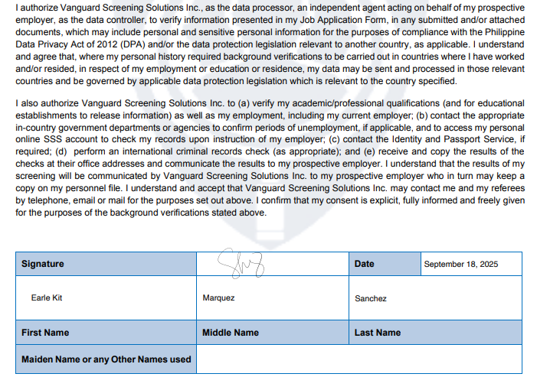

Findings:
What are his/her areas for improvement? | Continued growth through diverse projects, collaborative work, and opportunities to take on leadership and innovative initiatives.
Has he/she been noted for any disciplinary concerns while at school/in any organization he joined? | No.
What are the Candidate’s best qualities? | Kit is highly goal-oriented, organized, and proactive in exploring new opportunities. He is eager to learn and continuously seeks personal and professional growth.
How long have you known the candidate? | ~8 years
What are the Subject's strengths? | Strong initiative, eagerness to explore new technologies, clear focus on self-growth, consistent and organized execution.
What are the Subject's weaknesses? | None significant observed
Can you cite any issue that arose due to the candidate? | None.
What is the candidate's reason for leaving? | N/A
Were there any integrity issues? | No
Would you rehire the candidate? | N/A
Verifier's Name and Designation: | Cristopher David
Verifier's Contact Details: | 09496471857
Date Verified: | October 7, 2025

